|  |
| --- |
|  |
| 新概念 3 册 |
| Lesson29 Funny or not? |

Book

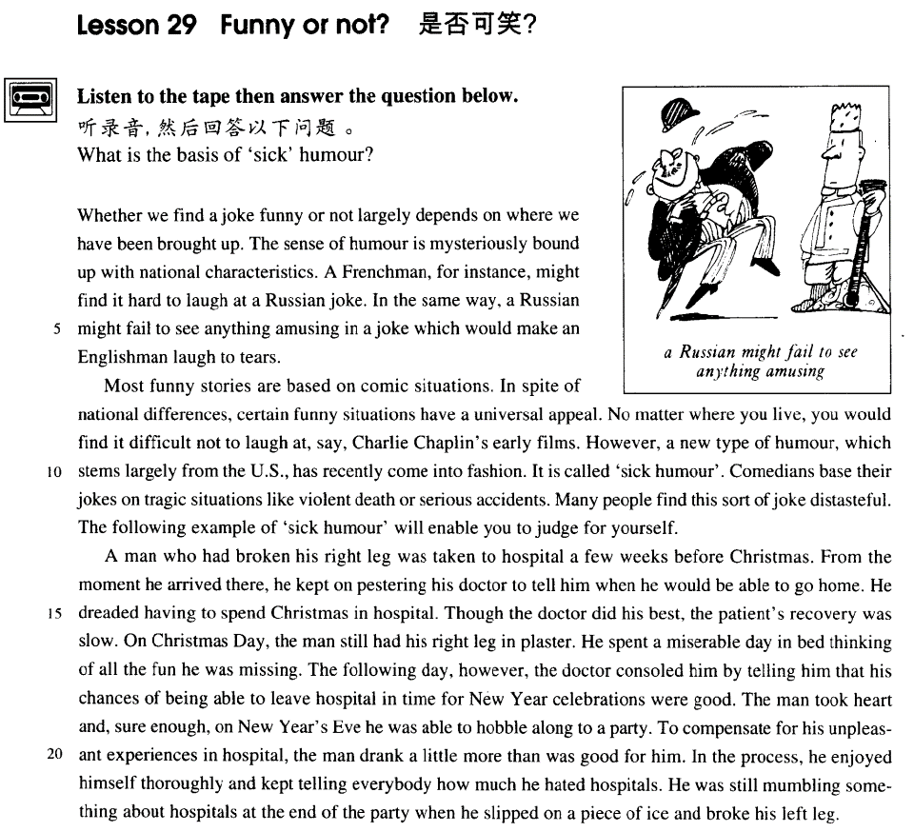

课文

Whether we find a joke funny or not largely depends on where we have been brought up.

我们觉得一则笑话是否好笑，很大程度取决于我们是在哪儿长大的。

The sense of humour is mysteriously bound up with national characteristics.

幽默感与民族有着神秘莫测的联系。

A Frenchman, for instance, might find it hard to laugh at a Russian joke.

譬如，法国人听完一则俄国笑话可能很难发笑。

In the same way, a Russian might fail to see anything amusing in a joke which would make an Englishman laugh to tears.

同样的道理，一则可以令英国人笑出泪来的笑话，俄国人听了可能觉得没有什么可笑之处。

Most funny stories are based on comic situations.

大部分令人发笑的故事都是根据喜剧情节编写的。

In spite of national differences, certain funny situations have a universal appeal.

尽管民族不同，有些滑稽的情节却能产生普遍的效果。

No matter where you live, you would find it difficult not to laugh at, say, Charlie Chaplin's early films.

比如说，不管你生活在哪里，你看查理.卓别林的早期电影很难不发笑。

However, a new type of humour, which stems largely from the U. S. , has recently come into fashion.

然而，近来一种新式幽默流行了起来，这种幽默主要来自美国。

It is called 'sick humour'.

它被叫作“病态幽默”。

Comedians base their jokes on tragic situations like violent death or serious accidents.

喜剧演员根据悲剧情节诸如暴死，重大事故等来编造笑话。

Many people find this sort of joke distasteful. The following example of 'sick humour' will enable you to judge for yourself.

许多人认为这种笑话是低级庸俗的。下面是个“病态幽默”的实例，你可据此自己作出判断。

A man who had broken his right leg was taken to hospital a few weeks before Christmas.

圣诞节前几周，某人摔断了右腿被送进医院。

From the moment he arrived there, he kept on pestering his doctor to tell him when he would be able to go home.

从他进医院那一刻时，他就缠住医生，让医生告诉他什么时候能回家。

He dreaded having to spend Christmas in hospital.

他十分害怕在医院过圣诞。

Though the doctor did his best, the patient's recovery was slow.

尽管医生竭力医治，但病人恢复缓慢。

On Christmas day, the man still had his right leg in plaster.

圣诞节那天，他的右腿还上着石膏，

He spent a miserable day in bed thinking of all the fun he was missing.

他在床上郁郁不乐地躺了一天，想着他错过的种种欢乐。

The following day, however, the doctor consoled him by telling him that his chances of being able to leave hospital in time for New Year celebrations were good.

然而，第二天，医生安慰他说，出院欢度新年的可能性还是很大的，

The man took heart and sure enough, on New Year's Eve he was able to hobble along to a party.

那人听后振作了精神。果然，除夕时他可以一瘸一拐地去参加晚会了。

To compensate for his unpleasant experiences in hospital, the man drank a little more than was good for him.

为了补偿住院这一段不愉快的经历，那人喝得稍许多了一点。

In the process, he enjoyed himself thoroughly and kept telling everybody how much he hated hospitals.

在晚会上他尽情娱乐，一再告诉大家他是多么讨厌医院。

He was still mumbling something about hospitals at the end of the party when he slipped on a piece of ice and broke his left leg.

晚会结束时，他嘴里还在嘟哝着医院的事，突然踩到一块冰上滑倒了，摔断了左腿。

词汇讲解

* **largely** ['lɑ:dʒli]adv. 在很大程度上，主要地

**largely**: [英文解释]to a great extent; chiefly

* His success was **largely** (在很大程度上)due to his hard work.
* The theory was **largely**(广泛的) adopted.

**mostly**: in most cases 在大多数情况下

* We’re **mostly** out on weekends.
* **comic** ['kɒmɪk] adj. 喜剧的；可笑的

**comedy** ***n.*** 喜剧；喜剧性；有趣的事情

**funny** ***adj.*** 有趣的，好笑的，滑稽的

**amusing** ***adj.*** 有趣的，好玩的；引人发笑的

**diverting** ***adj.*** 有趣的；令人快乐的

**tragic** ***adj.*** 悲剧的；悲痛的，不幸的

**tragedy** ***n.*** 悲剧；灾难；惨案

**farcical** ***adj.*** 滑稽的；闹剧的；引人发笑的

**farce** ***n.*** 闹剧；胡闹；笑剧

**dramatic** ***adj.*** 戏剧的；急剧的；引人注目的；激动人心的

**drama** ***n.*** 戏剧，戏剧艺术；剧本；戏剧性事件

* **universal** [ju:nɪ'vɜ:sl] adj. 普遍的、世界性的

【区分】

**cosmic** ***adj.*** 宇宙的

**cosmos** ***n.*** 宇宙

【形近】

**comic** ***adj.*** 喜剧的；滑稽的；有趣的

**comet** ***n.*** [天] 彗星

**cosmetics** ***n.*** [化工] 化妆品（cosmetic的复数）；装饰品

【近义】**universal**

**global** ***adj.*** 全球的；总体的；球形的

**international** ***adj.*** 国际的；两国（或以上）国家的；超越国界的；国际关系的；世界的

**world-wide** ***adj.*** 遍及全世界的

* English has now become an **international** language. Therefore, if you have a good command of this language, you hold the key to success.

**universally** ***adv.*** 普遍地；

* It is **universally** known that ...
* **comedian** [kə'mi:diən] n. 喜剧演员，丑角

**comedian** ***n.*** 喜剧演员；滑稽人物

**comedienne** ***n.*** 喜剧女演员

**comedy** ***n.*** 喜剧

**tragedian** ***n.*** 悲剧演员；悲剧作家

**tragedienne** ***n.*** 悲剧女演员

**tragedy** ***n.*** 悲剧

**leading role / part** 主角

**protagonist** ***n.*** 主角，主演；主要人物，领导者

**leading man** 男主角

**hero** ***n.*** 英雄；男主角，男主人公

**leading lady** 女主角

**heroine** ***n.*** 女主角；女英雄；女杰出人物

**supporting role** 配角

**extra** 临时演员

* **distasteful** [dɪs'teɪstfl] adj. 讨厌的，令人不愉快的

**be distasteful to sb.** 对某人来说是讨厌的

* It is **distasteful to me to say** this, but ......
* I **hate to say** this, but ......

【近义】

表达**“令人厌恶的”**的词汇：

**disgusting disgust**

**revolting revolt**

**repellent repel**

**repulsive repulse**

* **pester** ['pestə(r)] v. 纠缠，一再要求

**pester sb. for sth.** 为了某事纠缠某人

**pester sb. with sth.** 用某个东西纠缠某人

* He **pestered** me **with** complaints.
* He **pestered** me **for** money.

【近义】

harry ***vt.*** 折磨；掠夺；骚扰；使苦恼

harass ***vt.*** 使困扰；使烦恼；反复袭击

assail ***vt.*** 攻击；质问；着手解决

* **recovery** [rɪ'kʌvərɪ] v. 恢复原状；康复

**recovery from ...** 从…（不好的）状态中恢复原状

* **recovery from** illness
* **recovery from** defeat

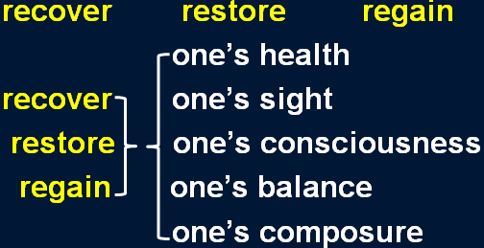

* **console** [kən'səʊl] v. 安慰，慰问

**console sb. for sth.** 因为某事安慰某人

**console sb. with sth.** 用某事安慰某人

* I **consoled** him **for** the loss of money.
* I **consoled** him **with** money.

**comfort** ***vt.*** 安慰；使（痛苦等）缓和

* **comfort** a dying man

**soothe** ***vt.*** 安慰；使平静；缓和 ***vi.*** 起抚慰作用

* **soothe** a crying baby

**calm sb. down** 让人平静下来

**condole with sb.** 吊慰某人

* The widow’s friends **condoled with** her at the funeral.
* **compensate** ['kɒmpenseɪt] v. 弥补，补偿

**compensate (sb.) for sth.** 弥补某人某事

* Nothing can **compensate (him) for his** loss.

**more than compensate for ...** 足以弥补

* **课后题：**Lesson 4
* 11．His rise in status more than ___C___ the loss of money. (11.14-15)

(a) pays back

(b) rewards

(c) **compensates for**

(d) values

* His rise in status **more than compensates for** the loss of money.

**make up for ...** 弥补损失

**redeem ... = compensate for**

**offset ... = compensate for**

课文讲解

# （第一段）

# Whether we find a joke funny or not largely depends on where we have been brought up.

**语法分析：**

Whether we find a joke funny or not（主句从句） largely depends on *where（做介词on的宾语从句） we have been brought up.*

知识点（1）

**语法：whether和if 从句**

表示“是否”时不能用 if 的几种情况：

**1、主语从句位于句首时，不能用 if**

* *~~If she likes the present~~* ~~is not clear to me.~~ X错误
* It is not clear to me ***if / whether*** *she likes the present*. √ （改正，放在句中）
* ***Whether*** *she likes the present* is not clear to me. √ （改正，句首改成whether）

**2、引导表语从句时，不能用 if**

* ~~The question is~~ *~~if~~* ~~we have enough money.~~ X错误
* The question is ***whether*** *we have enough money.* √改正

**3、引导同位语从句时，不能用 if**

* ~~You have yet to answer my question~~ *~~if~~* ~~I can count on your help.~~ X错误
* You have yet to answer my question *whether I can count on your help*. √改正

**4、作介词宾语时，不能用 if**

* ~~He was worrying about~~ *~~if~~* ~~he had hurt her feelings.~~ X错误
* He was worrying about ***whether*** *he had hurt her feelings*. √改正

**5、引导动词不定式时，不能用 if**

* ~~I don’t know~~ *~~if to~~* ~~see my doctor today.~~ X错误
* I don’t know *whether to see my doctor today*. √改正

**6、直接跟 or not 时，不能用 if**

* ~~Please tell me~~***~~if~~*** *~~or not~~* ~~you agree.~~ X错误
* Please tell me ***whether******or not*** *you agree*. √改正
* Please tell me ***if*** *you agree* ***or not*.** √改正

知识点（2）

**largely**: chiefly / to a great extent 很大程度上

知识点（3）

表达**“依赖、依靠、取决于”**：

**depend on ...**

**rest on ...**

**rely on...**

**ride on ...**

**hinge on ...**

**lean on ...**

**be dependent on ...**

**be based on ...**

**be built on ...**

**be founded on ...**

**be decided by ...**

**be dictated by ...**

**be determined by ...**

* Whether you find a joke funny or not largely **rests / relies / rides / hinges / leans on** where we have been brought up.
* Whether you find a joke funny or not **is** largely **dependent / based / built / founded on** where we have been brought up.
* Whether you find a joke funny or not is largely **decided / dictated / determined by** where we have been brought up.

知识点（4）

**bring up sb.** 拉扯大

* He was **brought up** by his step-mother.

**raise sb.** 抚养

**foster / adopt sb.** 领养某人

**adopted son** 养子

**adoptive parents** 养父母

**foster-parents** 养父母

**区分：**

**be brought up to do** 从小就…（用于一般线城市）

* The sad truth is that most of us have **been brought up to eat** certain foods and we stick to them all our lives.
* We have **been brought up to fear** insects.

# The sense of humour is mysteriously bound up with national characteristics.

知识点（1）

**the sense of humour** 幽默感

**the sense of pride** 自豪感

**the sense of honor** 荣誉感

**the sense of accomplishment**  成就感

**the sense of responsibility**  责任感

**the sense of superiority**  优越感

**the sense of inferiority** 自卑感

知识点（2）

**be bound up with ...** 与…紧密相连

**be closely connected with ...** 与…紧密相连

* Everyone’s future **is bound up with** the destiny of the Chinese nation.

**bind** 绑

**be bound to do ...** 必然会…、肯定会…

* On our road ahead, we **are bound to meet** with difficulties.

**be / feel bound to do ...** 觉得必须做某事

* I **felt bound to tell** him the truth.

**be / feel obliged to do ...** 觉得必须做某事

* However, as the evidence began to accumulate, experts from the Zoo **felt obliged to investigate**, for the descriptions given by people who claimed to have seen the puma were extraordinarily similar.

**bind sb. to do** 约束某人必须做某事

* The Kyoto Protocol **binds** each country **to** reduce the emission of greenhouse gases.

# A Frenchman, for instance, might find it hard to laugh at a Russian joke.

**语法分析：**

A Frenchman, *for instance（插入语）*, might find it（形式宾语） *hard（宾语补足语）* to laugh at a Russian joke（真正宾语）.

知识点（1）

**a** **Frenchman** 泛指法国人，谓语动词用**单数**

**the** **French** 泛指法国人，谓语动词用**复数**

an Englishman

the English / British

* **课后题：**
* 4．___A__, for instance, might find it hard to ... (11.3-4)

(a) The French

(b) A French

(c) A man in France

(d) If you were French

知识点（2）

* No matter where you live, you would find it（形式宾语） *difficult（宾语补足语）* not to（真正宾语）. laugh at, say, Charlie Chaplin's early films.

# In the same way, a Russian might fail to see anything amusing in a joke which would make an Englishman laugh to tears.

**语法分析：**

In the same way（介词短语当状语）, a Russian might fail to see anything *amusing（形容词后置,修饰amusing）***in**（介词短语当状语） **a joke which**（定语从句） **would make an Englishman laugh to tears.**

知识点（1）

表达**“同样的”：**

**In the same way**

**likewise**

**similarly**

**by the same token**

知识点（2）

**laugh to tears** 笑出眼泪

**be bored to tears / death** 无聊的要哭/要死

**laugh one’s head off** 大笑（夸张）

**clap one’s hands off** 鼓掌（夸张）

**cry one’s eyes out** 哭（夸张）

* **课文写法替换：**
* ... which would make an Englishman **laugh his head off.**

知识点（3）

**写作：**contrast 对比修辞 （课文第3句和第4局）

* A mother takes twenty years to make a man of her boy, and another woman makes a fool of him in twenty minutes.
* Men always want to be a woman’s first love; women have a more subtle instinct: what they like is to be a man’s last romance.

# （第二段）

# Most funny stories are based on comic situations.

# In spite of national differences, certain funny situations have a universal appeal.

知识点（1）

**universal**: 【同义替换】**international**, **global**, **world-wide**

**appeal**: 【同义替换】**attraction**, **charm**, **fascination**

**universal** **appeal** : 【同义替换】**an international attraction**、**a global charm、a world-wide fascination**

知识点（2）

**appeal to sb.** 吸引某人

* The idea never **appealed to me** very much, ...

**attract / charm / fascinate sb.** 吸引某人

* Cats never fail to **fascinate** human beings.

形容词形式：

**appealing**

**attractive**

**charming**

**fascinating**

# No matter where you live, you would find it difficult not to laugh at, say, Charlie Chaplin's early films.

**语法分析：**

No matter where you live（让步状语从句）, you would find it（形式宾语） *difficult（宾语补足语）* **not to（真正宾语，一直到句末） laugh at, say（插入语“比如说”）, Charlie Chaplin's early films.**

知识点（1）

**No matter where you live** = **Wherever you live, ......**

**语法复习：**（参见第8课：**疑问词 + ever 的含义**）

区分：

1. 疑问词 + ever 的含义可引导名词性从句；
2. no matter只能引导让步状语从句

* Whoever wants to sign up for the course is welcome. √
* No matter who wants to sign up for the course is welcome. X错误
* No matter who wants to sign up for the course, he is welcome. √改正
* **Whatever** project he works on is always successful.
* **No matter** what project he works on, **it is** always successful.

知识点（2）

**(let’s) say** 比如说（一般用于插入语）

* Why don’t we have a break until, **(let’s) say**, 10:45?
* Say / Let's say （充当连词，后面that可省略）(that) the journey takes three hours, you'll arrive at 2 o'clock.

# However, a new type of humour, which stems largely from the U. S. , has recently come into fashion.

知识点（1）

表达**“起源于”**：

**stem from …**

**originate in …**

**have its root in …**

* printing **stems from** China.
* printing **originates in** China.
* printing **has its root in** China.

**arise from ...** (倒霉的事)源自于…（摩擦、冲突、纠纷…）

* The argument **arose from** misunderstanding.

**come / hail from ...** 来自于…

* I **come / hail** from China.

知识点（2）

**come into fashion** 流行起来

* Miniskirts have **come into fashion**.

**be in fashion** 正在流行

**be out of fashion** 过时

**fashionable** （adj. 流行的） clothes / ideas / hairstyles …

知识点（3）

**come into** 进入…状态

**come into fashion** 开始流行

**come into use** 开始使用

* Computers first **came into use** in the early 1950s.

**come into effect** 开始生效

* The new seat-belt regulations **came into effect** last week.

**come into blossom** 开始开花

* The trees are late **coming into blossom** this year.

**come into being** 开始存在

* Up to now, historians have assumed that calendars **came into being** with the advent of agriculture, …

# It is called 'sick humour'.

# Comedians base their jokes on tragic situations like violent death or serious accidents.

知识点（1）

课文写法替换：

* Comedians **build** their jokes **on** tragic situations ...
* Comedians **found** their jokes **on** tragic situations ...

知识点（2）

**like** = 【书】such as

# Many people find this sort of joke distasteful. The following example of 'sick humour' will enable you to judge for yourself.

知识点（1）

课文写法替换：

* Many people find this sort of joke **unpleasant / disgusting / repellent / revolting / repulsive.** （形容词替换）
* Many people **dislike / hate / despise / abhor / detest / loathe / abominate** this sort of joke. （动词替换）
* This sort of joke **repels / revolts / repulses / disgusts / sickens** many people. （主语替换）

知识点（2）

表达**“下面的例子”：**

the **following** example

the **ensuing** example

the **under-mentioned** example

the example **below**

表达**“上面的例子”：**

the **previous** example

the **preceding** example

the **above-mentioned** example

the example **above**

知识点（3）

**enable sb. to do** 使某人能够…

* They devise hundreds of competitions which will **enable us to win** huge sums of money.

**allow / permit sb. to do** （人做主语）允许某人做…/（事物做主语）使某人能够…

**make it possible for sb. to do** 是某人能够…

* Radio and television have **made it possible for advertisers to capture** the attention of millions of people in this way.
* **课文写法替换：**
* ... will **allow / permit you to** judge for yourself.
* ... will **make it possible for you to judge for** yourself.

知识点（4）

**do sth for oneself** 亲自做某事

* So great is our passion for **doing things for ourselves**, that we are becoming increasingly less dependent on specialized labor.

# （第三段）

# A man who had broken his right leg was taken to hospital a few weeks before Christmas.

**语法分析：**

A man who had broken his right leg（定语从句） was taken to hospital *a few weeks before Christmas（时间状语）.*

知识点（1）

* **课文写法替换：**
* A man whose right leg had been broken ......

知识点（2）

表达“**去医院”**：强调功能不能加冠词

**take sb. to hospital**

**send sb. to hospital**

**go to hospital**

表达“**去住院”**：

**be in hospital**

**be hospitalized**

表达“出院**”**：

**leave hospital**

知识点（2）

**医院相关：**

**the outpatient department (OPD)** 门诊

**the inpatient department (IPD)** 住院部

casualty 【英】急诊室

emergency room (ER) 【美】急诊室

# From the moment he arrived there, he kept on pestering his doctor to tell him when he would be able to go home.

**语法分析：**

From the moment he arrived there（定语从句,修饰moment）（时间状语）, he kept on pestering his doctor *to tell him when he would be able to go home*（tell的宾语从句）*.* *（to后，目的状语）*

知识点（1）

表达“自从”：

1. **from没有时态限制**

* From the moment (**when**) he arrived there … （省略**when**，定语从句）
* From the moment (**at which**) he arrived there …（省略**at which**，关系副词）
* From the moment (**that**) he arrived there …（省略**that**，关系副词）
* From the moment (**/**) he arrived there … （空，省略**when**）

1. **since 要用完成时**

* Since the moment he arrived there, he **had kept** on pestering ...

知识点（2）

**keep (on) doing** 不停的做某事…

* Why do you **keep (on) making** the same mistakes?
* How can I explain if you **keep (on) interrupting** me?
* In the process, he enjoyed himself thoroughly and **kept telling** everybody how much he hated hospitals.

# He dreaded having to spend Christmas in hospital.

知识点（1）

**dread + n. / doing** 害怕某事（发生）

* She **dreads getting** old.

**dread to do** 一做某事就害怕

* I **dread to think** what will happen if I fail.
* She dreads to get old. X错误

# Though the doctor did his best, the patient's recovery was slow.

表达“竭尽全力做某事”：

**do / try one’s best to do**

**do / try one’s utmost to do**

**do everything / all one can to do**

* **课后题：**Lesson29
* 9.Though the doctor ___D___... (1.15)

(a) worked very well

(b) could not have been better

(c) was extremely skilled

(d) **did all he could** 竭尽全力

**give one’s all to do** 竭尽全力

**spare no effort to do** 不遗余力

**go all out to do** 竭尽全力

**go to great lengths to do** 竭尽全力做某事

* The man **went to great lengths to prove** that the diamonds were real.

# On Christmas day, the man still had his right leg in plaster.

知识点（1）

at Christmas  **介词“at”表示期间**

on Christmas Day **介词“on”表示当天**

on Easter Day

on weekends 周末 【美】

at weekends 周末 【英】

* The only regular visitors to the monastery in winter are parties of skiers who go there **at** Christmas and Easter.

知识点（2）

* **课文写法替换：**
* ..., the man’s right leg was still in plaster.

# He spent a miserable day in bed thinking of all the fun he was missing.

**语法分析：**

He spent a miserable day in bed thinking of all the fun he was missing（定语从句，修饰missing）. （伴随状语）

# The following day, however, the doctor consoled him by telling him that his chances of being able to leave hospital in time for New Year celebrations were good.

**语法分析：**

The following day（时间状语）, *however（插入语）*, the doctor consoled him *by telling him* ***that his chances of being able to leave hospital in time for new year celebrations（介词短语，修饰*chances*） were good.*** *（that后到结尾，宾语从句）（by后到结尾，方式状语）*

知识点（1）

**chance** 可能性

* The following day, however, the doctor consoled him by telling him that **his chances of** being able to leave hospital in time for new year celebrations **were good**（可能性大）.
* As she is not rich, the **chances** that she will ever be able to afford such purchases **are remote（**可能性小）; but she is never sufficiently strong-minded to be able to stop the practice.

**one’s chances of doing … are good/high** 某人做某事的可能性**大**

**one’s chances of doing … are small/slight/remote** 某人做某事的可能性**小**

**the chances that … are good/high**

**the chances that … are small/slight/remote**

* **造句**：他赢得这次比赛的可能性很小。
* His **chances** **of** winning the game **are** **remote**.
* The **chances that** he will win the game **are** **remote**.

# The man took heart and sure enough, on New Year's Eve he was able to hobble along to a party.

知识点（1）

**take heart** = **be encouraged** 收到鼓舞

**lose heart** 灰心丧气

辨析：**lose one’s heart to ...** 爱上某人

**sure enough** 果然

**as expected** 果然

知识点（2）

**eve** 重要日期的前一夜

知识点（3）

**along** 课文中不是介词，表示向前

# To compensate for his unpleasant experiences in hospital, the man drank a little more than was good for him.

**语法：**than后直接加谓语动词

than was good for him

... than （what） was good for him.

* It seems that man was making a real effort to understand the seasons 20,000 years earlier **than has been supposed.**
* **考试真题：**
* The project requires more labor than ___A___ because it is extremely difficult.

A．has been put in

B．have been put in

C．being put in

D．to be put in

* **考试真题：**
* We often advise him not to drink more wine ___B___ is good for his health.

A．as

B．than

C．that

D．but

* **考试真题：**
* The experiment requires more money than ___C___.

A．have been put in

B．being put in

C．has been put in

D．to be put in

* **考试真题：**
* The indoor swimming pool seems to be a great deal more luxurious than ___A__.

A．is necessary

B．being necessary

C．to be necessary

D．it is necessary

# In the process, he enjoyed himself thoroughly and kept telling everybody how much he hated hospitals.

**语法分析：**

In the process（时间状语）, he enjoyed himself thoroughly and kept telling everybody *how much he hated hospitals（宾语从句）.*

知识点（1）

..., **he had a good / great time** ... 过的很开心

知识点（2）

* **课文写法替换：**
* ... kept telling everybody **to what extent** he hated hospitals.
* **To what extent** do you love her? I’ll die for her.

# He was still mumbling something about hospitals at the end of the party when he slipped on a piece of ice and broke his left leg.

**语法分析：**

He was still mumbling something about hospitals（后置定语,修饰something） *at the end of the party when he slipped on a piece of ice* ***and*** *broke his left leg（时间状语）*.

知识点（1）

**语法：**主句 (进行时 / be about to do) + when ... “when”应译为“这时”或“突然； （罕见句型：句子的重点信息在when引导的从句里）

* He **was still mumbling** something about hospitals at the end of the party **when** he slipped on a piece of ice and broke his left leg.
* The idea never appealed to me very much, but one day, after a heavy shower, I happened **to be walking** in my garden **when** I noticed a huge number of snails taking a stroll on some of my prize plants.
* The Karen had **been sailing** in a convoy to Russia **when** she was torpedoed by an enemy submarine.
* The morning passed rapidly and Frank **was about to leave** **when** he noticed a large packing case lying on the floor.

知识点（2）

**slip** 滑

**slip on a piece of ice**  在冰上滑倒

**trip over a stone** 在石头上绊倒

**a slip of the pen** 小失误

**a slip of the tongue** 口误